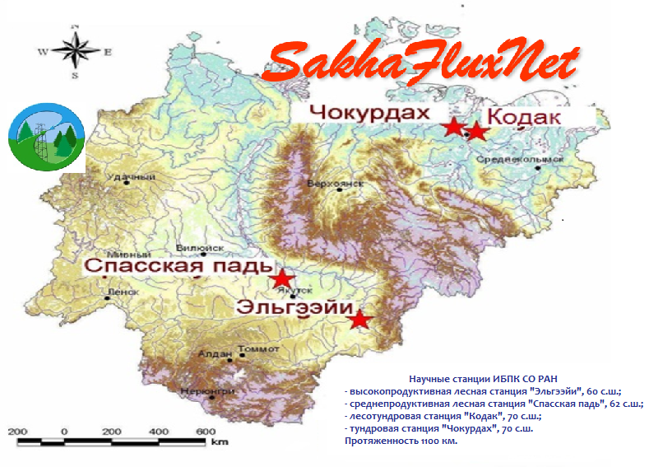

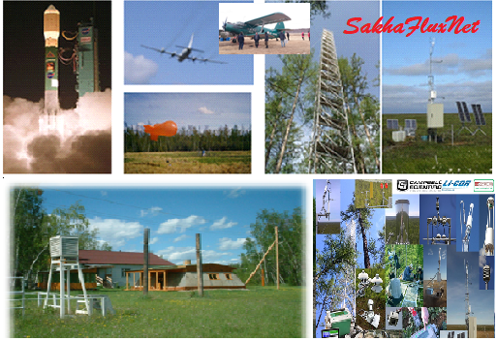

International Summer Field School
"Greenhouse Gases and Climate:
Monitoring, Manipulation, Modeling and Management"

July 16 - 26, 2024
Experimental Forest Station “Spasskaya Pad”
Institute for Biological Problems of Cryolithozone SB RAS (IBPC)
Federal Research Center “Yakut Scientific Center SB RAS”

PROGRAM
Link to the Zoom conference*
https://us02web.zoom.us/j/85153634511?pwd=5MQPbfsZ6mm2pub4KEdRMbN9vXbHZi.1

July 16 | 09:30 - 10.00 – Registration of participants  Yakut Scientific Center SB RAS, Conference Hall, Yakutsk, 2 Petrovskogo st.  10:00 - 10:20 – Welcome speech  Mikhail LEBEDEV – Dr. Sci., Prof., Corresponding member of the Russian Academy of Sciences, General Director of the Federal Research Center "Yakut Scientific Center SB RAS", Yakutsk, Russia  Innokentiy OKHLOPKOV – PhD, Director of the IBPC SB RAS, Federal Research Center "Yakut Scientific Center SB RAS", Yakutsk, Russia  Plenary sessions  Moderator Mikhail LEBEDEV, Dr. Sci., Prof., Corresponding member of the Russian Academy of Sciences  10:20 - 10:50 Alexey ROZANOV - Academician of the Russian Academy of Sciences, Paleontological Institute named after A.A. Borisyak RAS, Moscow, Russia  SOME THOUGHTS ON THE DEVELOPMENT OF THE ORGANIC WORLD OF THE PRECAMBRIAN AND BEFORE THE FORMATION OF THE EARTH  10:50 - 11:20 Sergey ROZHNOV - Academician of the Russian Academy of Sciences, Paleontological Institute named after A.A. Borisyak RAS, Moscow, Russia  GEOBIOLOGICAL EVENTS RELATED TO CARBON AND OXYGEN CYCLES IN THE PROTEROZOIC AND PALEOZOIC  11:20 – 11:50 Trofim MAXIMOV, Dr. Sci., IBPC SB RAS, Federal Research Center "Yakut Scientific Center SB RAS", Yakutsk, Russia  STUDY OF GREENHOUSE GASES WITHIN PERMAFROST ECOSYSTEMS OF THE NORTH-EASTERN EURASIA IN THE CONTEXT OF GLOBAL CLIMATE WARMING AND INCREASED ANTHROPOGENIC PRESSURE AT THE END OF THE XXth AND THE BEGINNING OF THE XXI CENTURY  11:50 - 12:05 Coffee break  Moderator Roman PETROV, PhD  12:05 - 12:25 Alexander FEDOROV, Dr. Sci., Institute of Permafrost Science SB RAS, Yakutsk, Russia  IMPACT OF CLIMATE CHANGE AND PERMAFROST ON PERMAFROST LANDSCAPES AND ECOSYSTEMS  12:25-12:45 Roman DESYATKIN, Dr. Sci., IBPC SB RAS, Federal Research Center "Yakut Scientific Center SB RAS", Yakutsk, Russia  SCALE OF THERMOKARST DEGRADATION OF THE SOIL COVER AND DISTURBANCE OF THE WATER BALANCE OF THE CRYOLITHOZONE  12:45 – 13:05 Taro NAKAI, PhD, National Taiwan University, Taiwan, China  INTRODUCTION TO FOREST MICROMETEOROLOGY  13:05 – 14:15 – Lunch  Moderator Alexander FEDOROV, Dr, Sci.,  14:15 – 14:45 Yong LI, Dr. Sci., Prof., Institute of Atmospheric Physics, Chinese Academy of Sciences (IAP-CAS), Beijing, China  MITIGATING N₂O EMISSIONS FROM CHINA CROPLANDS FOR GREEN AGRICULTURE  14:45 – 15:15 Shamil MAKSYUTOV, PhD, National Institute for Environmental Studies, Tsukuba, Japan  CARBON BALANCE: ECOSYSTEM SINK AND ATMOSPHERIC CO2 MEASUREMENTS  15:15 - 15:45 Ayumi KOTANI, PhD, Nagoya University, Nagoya, Japan  FOREST CARBON CYCLE ACCORDING TO FLUX TOWER OBSERVATIONS  15:45 – 16:15 Irina KISELEVA, PhD, Ural Federal University, Ekaterinburg, Russia  CO2-ASSIMILATION — THE FIRST STEP OF CARBON SEQUESTRATION: LIMITATIONS FOR PHOTOSYNTHESIS.  16:15 – 16:35 – Coffee break  Moderator Trofim Maximov, Dr.Sci  16:35 – 17:05 Nataliya LUKINA, Dr. Sci., Prof., Corresponding member of the Russian Academy of Sciences, Center for Forest Ecology and Productivity, Moscow, Russia  NATIONAL MONITORING SYSTEM FOR CARBON POOLS AND GREENHOUSE GAS FLUXES  17:05 – 17:35 Xunhua ZHENG, Dr. Sci., Prof., Institute of Atmospheric Physics, Chinese Academy of Sciences (IAP-CAS), Beijing, China  MEASUREMENT TECHNIQUES OF GHG FLUXES FROM TERRESTRIAL ECOSYSTEMS  17:35 – 18:05 Roman PETROV, IBPC SB RAS, Yakutsk, Russia  STUDY METHODOLOGIES ON CARBON CYCLE COMPONENTS OF ECOSYSTEMS
July 17 | 9:00 Departure to the scientific station "Spasskaya Pad" IBPC SB RAS (30 km north of Yakutsk, 1.5-2 hour), accommodation  13:00 - 14:00 Lunch  14:00 – 14:30 Olga KURICHEVA, PhD, A.N. Severtsov Institute of Ecology and Evolution RAS, Moscow, Russia  GLOBAL EDDY-COVARIANCE MEASUREMENT NETWORKS. ORGANIZATION AND RESULTS.  14:30 – 16:30 Yuri ZHEGUSOV, PhD, IBPC SB RAS, Yakutsk, Russia  CLIMATE CHANGE SOCIOLOGY AS A NEW DIRECTION OF ENVIRONMENTAL SOCIOLOGY  16:30 – 17:15 INRODUCING PARTICIPANTS AND BRIEF PRESENTATIONS OF THE RUSSIAN AND FOREIGN WORKING GROUPS FOR CARBON STUDIES**  17:15 – 18:45 Breakdown into 4 research groups and discussions on scientific plans.  Moderators are PETROV Roman, PhD (Carbon flux group), MAKSIMOV Ayaal (Photosynthesis group), STAROSTIN Egor (Soil respiration group), ZHEGUSOV Yuri, PhD (Scientific diplomacy group).  Guidance to Cultural program*.  19:00 – 20:30 Welcome Party  20:30 – 22:30 Ethno-music program
July 18 | 08:00 – 09:00 Breakfast  9:30 – 12:30 Groups work: photosynthesis, soil respiration, carbon fluxes and scientific diplomacy  13:00 - 14:00 Lunch  14:30 – 18:00 Groups work: photosynthesis, soil respiration, carbon fluxes and scientific diplomacy  19:00 – 20:00 Dinner  20:30 – 22:30 Cultural program***
July 19-23 | 08:00 – 09:00 Breakfast  09:30 – 12:30 Groups work: photosynthesis, soil respiration, carbon fluxes and scientific diplomacy  13:00 - 14:00 Lunch  14:30 – 18:00 Groups work: photosynthesis, soil respiration, carbon fluxes and scientific diplomacy  19:00 – 20:00 Dinner  20:30 – 22:30 Cultural program**
July 24 | 08:00 – 09:00 Breakfast  09:30 – 12:30 Groups work: photosynthesis, soil respiration, carbon fluxes and scientific diplomacy  13:00 - 14:30 Lunch  14:30 – 17:00 Groups work: photosynthesis, soil respiration, carbon fluxes and scientific diplomacy  17:45-18:45 SCIENTIFIC REPORTS OF 4 RESEARCH GROUPS  19:00 – 20:00 FAREWELL DINNER  20:30 – 22:00 Free program
July 25 | Leaving to Yakutsk at 10:00  City excursions (Mammoth Museum, Permafrost Kingdom etc.)
July 26 | Lena Pillars excursions, 7:00- 20:00

* Zoom Conference
1. Connect from a PC, Mac, iPad, or Android device
Join the conference
If the button does not work, copy this link and copy it into the browser's address:
https://us02web.zoom.us/j/85153634511?pwd=5MQPbfsZ6mm2pub4KEdRMbN9vXbHZi.1
In order to protect this conference, please, do not share this link in the public domain.

2. Connect via the audio device
United States of America:
+16892781000, 85153634511# or +17193594580,85153634511#
or:
+1 689 278 1000, +1 719 359 4580, +1 929 205 6099, +1 253 205 0468, +1 253 215 8782, +1 301 715 8592, +1 305 224 1968, +1 309 205 3325, +1 312 626 6799, +1 346 248 7799, +1 360 209 5623, +1 386 347 5053, +1 507 473 4847, +1 564 217 2000, +1 646 931 3860, +1 669 444 9171, +1 669 900 6833

Conference ID: 851 5363 4511
Access code: 049914

** INRODUCING PARTICIPANTS – 5-10 min overview about yourself and scientific activity using ppt;
***The cultural program includes a presentation of various regions of Russia and China (a brief overview of socio-economic development of the region, cultural and natural attractions, folk songs, dances, local folk games, etc.).

Dear Participants, it would be great and interesting, if you could demonstrate your national costume at the Cultural Program.

