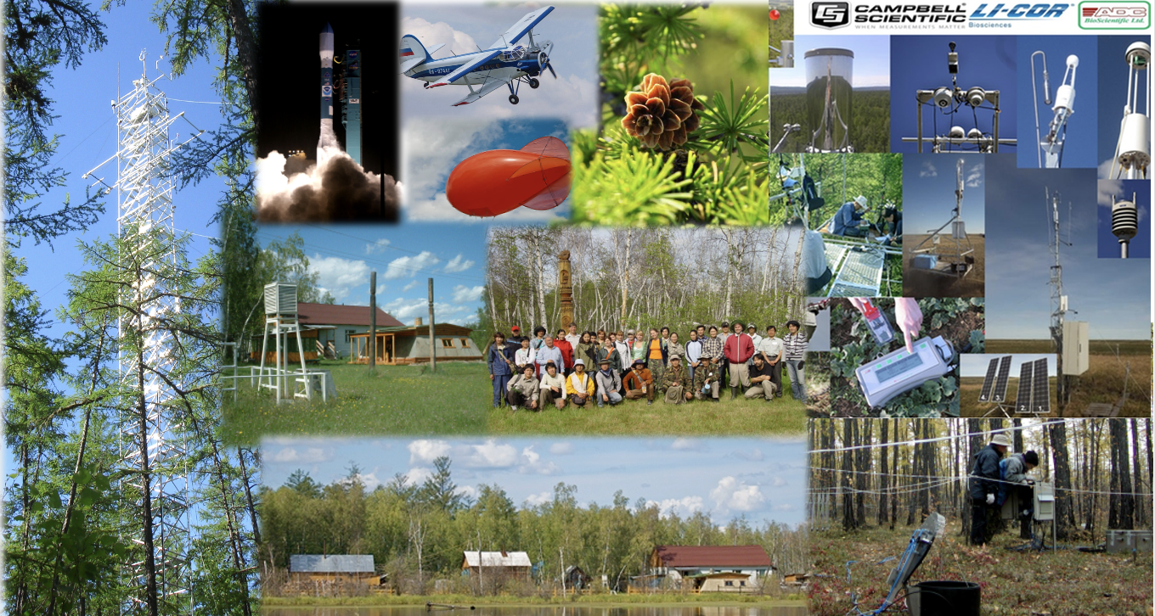
International summer field school
"Greenhouse Gases and Climate:
Monitoring, Manipulation, Modeling and Management"

Institute of Biological Problems of Cryolithozone SB RAS (IBPC)
Yakut Scientific Center SB RAS
August 7 - 13, 2023

Dear colleagues,

International scientific cooperation on the problem of global climate change has been developing in the vast permafrost territory of the North-East of Russia for 32 years. Within the framework of 53 international and intergovernmental research and educational projects (18 countries of the world), a unique scientific system SakhaFluxNet has been created to conduct interdisciplinary scientific research on solving fundamental issues. Research work reveal the full picture of the state of environment, the nature of the interaction of all its parts (atmosphere, biosphere, hydrosphere, cryolithosphere), their impact on biodiversity, implementation of forecasting and softening of possible directions and consequences of global environment changes using the latest scientific and innovative instrumental base and devices. SakhaFluxNet monitoring observation network for the study of greenhouse gases and climate is also a part of the international scientific networks GlobalCarbon, EuroFlux, AsiaFlux, INTERACT, PAGE21 and ScanNet. The complex system SakhaFluxNet includes all the largest bioclimatic zones of
the North-East of Russia – tundra, forest-tundra and forest. The system consists of four fully equipped research stations – Spasskaya Pad (Central Yakutia), Elgeeii (South-Eastern Yakutia), Chokurdakh and Kodaс in Northeastern Yakutia. Such an extensive network of world level monitoring stations in the North-East of Russia is the only one on the territory of the Russian Federation and has no analogues, both in scientific instrumental providing and the number of parameters studied. Monitoring studies initiated by international scientific forces are expanding both in terms of coverage of the territory and the number of studied parameters – space, geological, physico-technical, sociological and biological.

Summer field school "Greenhouse gases and climate: monitoring, manipulation, modeling and management" will be held at the international forest research station "Spasskaya Pad" (the Institute of Biological Problems of the Cryolithozone SB RAS, Yakutsk) from August 7 to 13, 2023. The field school is supported by the Federal Research Center "Yakutsk Scientific Center SB RAS", the Ministry of Higher Education and Science of the Russian Federation."

The purpose of the international field school
- to provide opportunity for scientists dealing with the modern problem of climatically active substances monitoring and transboundary carbon regulation to gain a broad understanding and knowledge about the field of decarbonization
- expand knowledge and use it in practice to organize a national system of carbon polygons and farms
- use scientific diplomacy for the interaction of academic science and society, as well as stakeholders

During the international school will be discussed
- a wide range of disciplines such as Earth and Environmental Science, Climatology, Meteorology,
Plant Physiology, Ecology, Sociology, etc.,
- development of joint scientific projects on greenhouse gases, including field research, development of modern carbon monitoring techniques,
- analysis of the data obtained and presentation of research results on the following scientific topics: photosynthesis and plant respiration; soil respiration; flows of energy, water and greenhouse gases; carbon pools, ecosystem disturbance; other environmental problems in the period of great challenges of our time.

Well-known biogeochemistry scientists from European Union, USA, Japan, China, Russia and other countries are expected to attending as lecturers and participants.

We invite to take a participation all scientists and stakeholders who deals with the problem of decarbonization and development of a national system of carbon polygons and farms in Russia. Please, note, for working at a scientific station you need a field uniform (cloth) and repellents.

Main topics
• Greenhouse gas monitoring
• Manipulation with greenhouse gases
• Carbon modeling and hybrid intelligence
• Management: scientific diplomacy.

Language - Russian and English

Approximate schedule
August 7, 2023, 09:30 a.m.
Venue: Conference Hall of the Yakut Scientific Center SB RAS, Yakutsk
• Opening ceremony
• Plenary presentations

August 8-11, 2023, 09:00 a.m.
Departure to the scientific station "Spasskaya Pad" IBPC SB RAS (it is located in 30 km north of Yakutsk, near one-hour drive).

August 12, 2023
Excursions around the city (Mammoth Museum, Permafrost Kingdom, etc.)

The Organizing Committee of the school
Mikhail LEBEDEV, corresponding member, Yakut Scientific Center SB RAS, Russia
Innokenty OKHLOPKOV, PhD., IBPC SB RAS, Russia
Trofim MAXIMOV, Dr.Sci., IBPC SB RAS, Russia
Shamil MAKSYUTOV, PhD, National Institute for Environmental Studies, Japan
Yury ZHEGUSOV, PhD., IBPC SB RAS, Russia
Susan M. NATALI, Professor, Arctic Program, USA
Taro NAKAI, PhD., Taiwan University, Taiwan
Ayumi KOTANI, PhD., Nagoya University, Japan
Stanislav KSENOFONTOV, PhD., University of Northern Iowa, USA
Ruslan SHAKHMATOV, PhD., Hokkaido University, Japan

Key dates
• Applications for participation are accepted until 15 July, 2023. The number of participants is limited.
Please, send the applications to the e-mail address gcoe_russia@mail.ru. Details on the website http://ibpc.ysn.ru/

Contributions
The cost of participation is 40 000 (forty thousand) rubles, including transportations, accommodation and meals at the scientific station, coffee, tea and buffet).
Excursions around Yakutsk are at the expense of the school participant.

Accommodation
The middle cost of the hotel rooms starts from 2500 rubles. If you need help with accommodation, please let us know, the hotel booking will be arranged by the Organizing Committee, please email to gcoe_russia@mail.ru (Alekseeva Alexandra).

APPLICATION
International Summer Field School
"Greenhouse Gases and Climate:
Monitoring, Manipulation, Modeling and Management"
Yakutsk
August 7-13, 2023

Name
Citizernship
Affiliation

Position, research degree
Post address
Phone number
Email
Days of arrival and departure (date and time)
Participation in the tour around Yakutsk city on the 12th of August: yes/no

